**MIDTERM TEST- A1.2 (90’)**

**Name: …………………………… Class: ……………………..**

1. **LISTENING**

**Part 1. Put the tick to the right answer**

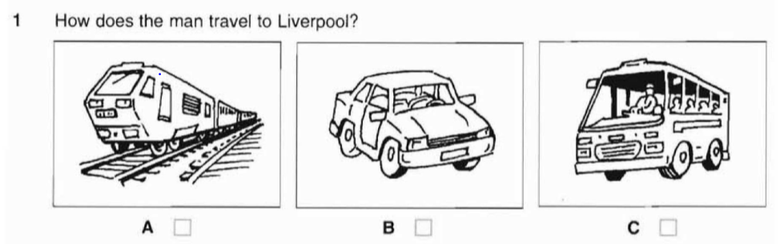



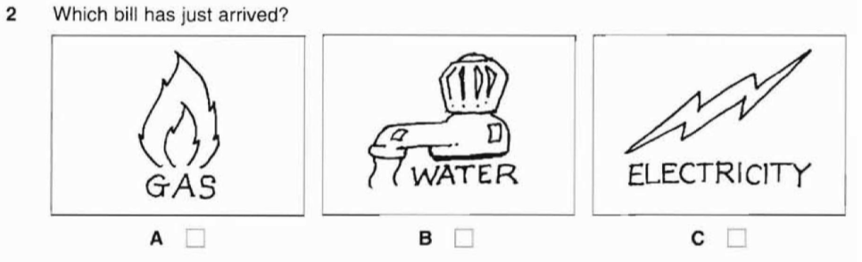



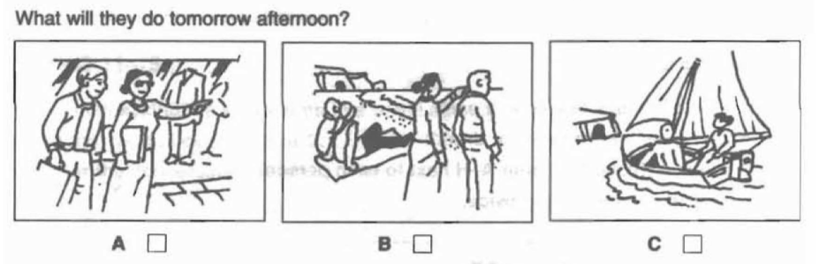



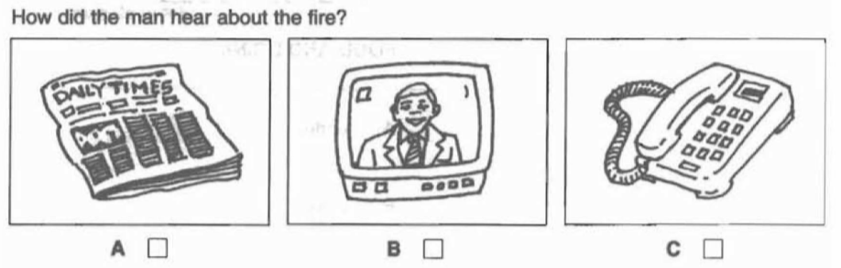



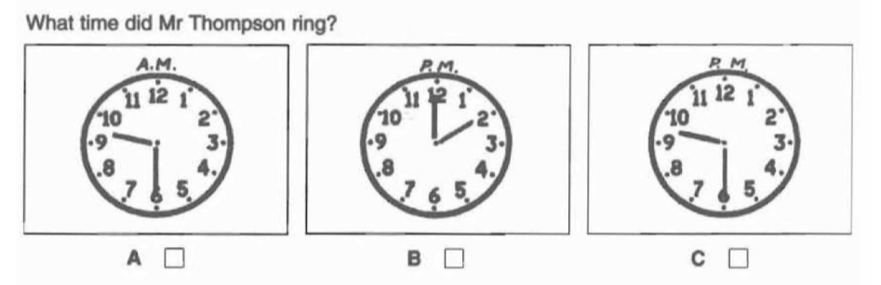

**Part 2: Listen to a man asking for information in a travel agency. Tick A, B or C to answer.**

6. The plane leaves at

A. 12a.m. B. 2 p.m. C. 3 p.m.

7. The bus station is in

A. Bill Street B. Hill Street C. Mill Street

8. The journey to the airport takes

A. 1 hour 15 minutes B. 1 hour 30 minutes C. 1 hour 45 minutes

9. The man’s ticket to Buenos Aires will cost?

A. £240 B. £300 C. £320

10. The coach costs

A. £13.50 B. £14.50 C. £30.50

**Part 3. You will hear a girl talking about her brother, Toni. Listen and complete the question.**

**Toni’s had an accident**

He’s hurt his: leg

Name of hospital: 11 the city hospital……………………………………………….

Room: 12 …living room……………………………………………

Floor: 13 ………3rd……………………

Visiting hours: 14 4 p.m. to 7.p.m…………………….. every day

Please take: 15 ………magazines………………………………………………………

**PART 4. Listen to the conversation about a farm and fill in the blank with suitable word**

**PARK FARM**

To see: Farm animals

Food in: 16: ……black………………..Cat tea room

Opens at: 17. ……10.30 a.m……………………………….

Closes at: 5 p.m

Family ticket costs: 18. ……17……………………………….

Don’t bring: 19. ………your dog……………………………….

Not far from: 20………………the river…………………………

**READING & WRITING**

**Part 1: Grammar and Vocabulary (20 points)**

1. ……..helps people in court.

A. A lawyer B. A doctor C. An architect D. A designer

2. What is “hello” …………..Vietnamese?

A. on B. in C. to D. of

3. She ……..in Australia and has two adopted ………….

A. live/ children C. lives/ children

B. lives/ child D. lives/ childrens

4. She usually………her breakfast every morning.

A. does B. do C. makes D. make

5. We are an international school, ………..students come from different countries

A. our B. my C. their D. us

6. We often go to the………in………….when it is quite hot.

A. beach/ summer B. beach/ winter

C. beach/ Christmas D. beach/ holiday

7. He is a…………He works in a……..in Paris.

A. chef/ restaurant B. chef/ book shop

C. an engineer/ restaurant D. a pilot/ school

8. Do you have a………..lifestyle?

A. health B. healthy C. healthily D. healths

9. We often ……….Christmas day…..the beach.

A. use/ on B. spend/ on C. have/ in D. spend/ in

10. Can I…….a ticket ……….the trip to London?

A. have/ for B. have/ on C. has/ for D. has/ on

**Part 2 (5 points): Read the short reading and circle the correct answer**

Australia is a very large nation covering nearly 8,000,000 square kilometers and a wide range of climates may be found in different parts of the country. The southern half of Australia has four seasons each year and snow falls on the highest mountain peaks. However, the northern half of Australia lies in the tropics and like many south-East Asian countries there are only two seasons each year; the wet and the dry season. The main difference is that Australia is in the southern hemisphere, the seasons are the opposite of those in Asia. In the summer the fierce sun heats the dry inland air which rises, causing moist cool air from the sea to follow inland. In the summer months of December, January and February, when temperatures are at a maximum, these moist winds carry rain to the inlauyyxind desert of Australia. In the winter months of June, July and August, the cool air over the inland desert blows out towards the sea, and because this wind carries very little moisture, no rain falls.

1. What is the best title of the reading?

a. Life in Australia c. Weather in Australia

b. How to travel in Australia d. Seasons in Australia

2. How many seasons are there in southern Australia?

a. two b. Three c. four d. six

3. Where does snow fall in Australia?

a. the northern half b. the southern half c. the sea d. the desert

4. According to the reading, when are the winter months in Australia?

a. from Dec to Feb b. from Mar to May c. from Jun to Aug d. from Sep to Nov

5. What does those in ‘the seasons are opposite of those in Asia’ refer to?

a. climates b. Temperatures c. the months d. the seasons

**Part 4. Read the passage carefully then answer the questions. (5 pts)**

|  |
| --- |
| People of ethnic minorities in Phu Yen celebrate Hoi Mua Festival every March. It is held to thank the Rice God for the crop, and to pray for better crops in the future. Families also worship their ancestors and parents on this occasion. Villagers voluntarily contribute money and other things to celebrate the festival.  In this festival monks are invited to preach. People play drums, sing songs and dance. They also drink rice wine through a long thin bamboo tube. There are some other activities such as cultural shows, buffalo races, and traditional games. The festive atmosphere is felt around all the villages. |

**Questions:**

1. Who in Phu Yen celebrate Hoi Mua Festival every March. People of ethnic minorities in Phu Yen celebrate Hoi Mua Festival every March.

2. When is it held? It is held every March.

3. What do villagers voluntarily contribute to celebrate the festival? Villagers voluntarily contribute money and other things to celebrate the festival.

4. What do people drink in this festival? People drink rice wine through a long thin bamboo tube in this festival.

5. Where is the festive atmosphere felt? The festive atmosphere is felt around all the villages.

**Part 5. Read the text and complete the summary with suitable words from the text. (13 points)**

**Ex 1:** There are several things to remember if you are applying for a new job. Most companies advertise their vacancies in the newspapers, and there are normally a lot of applicants for each post. Therefore, a good letter of application is very important. You should enclose with it your curriculum vitae so that the employer knows about your qualifications and experience. If you are applying for a large company, address your letter to the personnel manager, who deals with appointing new staff. If you are invited to an interview, make sure you are suitably dressed and on time. You may ask about promotion prospects as well as further training, the salary and holiday arrangements.

**Summary:**

When you apply for a new job, you should (1) remember several points. First, it’s very important to have a good (2) letter of application Second, let the employer know your qualifications and experience by enclosing your (3) **curriculum vitae**. Finally, send a letter to the (4). personnel managerif. you are applying for a large company. When coming to the interview, don’t forget to dress suitably and be (5) on time

**Ex 2:** The means of transportation has changed and improved over many centuries. Long ago, animals such as horses, buffaloes and camels were used by man for transportation purposes. They took a long time to complete the journeys, especially when transporting goods. In 1825, George Stephenson's opening of the first railway marked a significant progress in the history of transportation. Trains were in popular demand because they could carry more people and loads. More importantly, they ran faster than animals. Motor vehicles were first invented in the eighteenth century. These vehicles were preferred by many people as they do not run on tracks and hence do not have fixed routes. Travelers can then plan their own routes to suit their convenience, especially when the destinations are places like small towns or remote areas.

**Summary**

The means of transportation has improved over time. In ancient times, man made use of (6) animals .like the horses to transport goods. The journeys usually (7) took a long time. (8) people were preferred to animals since its invention, as they carried more (9) as and goods and travel (10) faster Motor (11) vehicles proved more superior to trains as they do not (12) run on rails. Hence, they are able to reach small (13) towns and remote areas where tracks are not available.

**Part 6. Complete the sentences with the following suggestions (10 points)**

1. I/meet/English/man/blue eyes/last/night.

I met an English man with blue eyes last night.

1. The/manager/be/so sick/that/he/not go/work/yesterday.

The manager was so sick that he did not go to work yesterday.

1. The/weather/too bad/us/go/picnic

The weather was too bad for us to go for a picnic.

children/ busy/collect/shells/beach

The children were busy collecting shells on the beach.

1. Father/work/engineer/foreign company

My father works as an engineer for a foreign company.

1. It/not easy/speak/English/fluently/his/age

It is not easy to speak English fluently at his age.

1. I/love/girl/name/Alice

I love a girl named Alice.

1. He/live/country/large/house/big/garden.

He lives in the country in a large house with a big garden

1. She/love/travel/abroad/her/friends.

She loves to travel abroad with her friends

1. Mother/often/go/supermarket/buy/food/family.

My mother often goes to the supermarket to buy food for the family.

**Part 7. Write a postcard to your pen pal to tell about one of your favorite places in your hometown. You should write 50-60 words.**

Suggestions: Where is the place?

How does it look like?

What is special about the place?

What do you do when you come there?

Dear [an],

Greetings from HA NOI! One of my favorite places here is Hoan Kiem Lake. It's a serene and picturesque spot in the city center, surrounded by ancient trees and bustling streets. The Turtle Tower in the middle of the lake is truly special. I love to take peaceful walks and enjoy the scenic beauty whenever I visit.

Best wishes, [AN]